Monthly Report
Date | am/pm | Contents | Other
14 Mar  (Fri) | am | ○Move to MDK from PP
 | pm | ○School Monitoring  Pou Rolar PS
15 Mar  (Sat) | am | ○School education  Lao Romeat PS, Ou Te PS  ○HC Monitoring  Pichreada HC | (Due to meeting day will be fallen on 15th March at Sre Ampom PS)
 | pm | ○School monitoring  Leng Choung PS
17 Mar  (Mon) | am | ○School Monitoring  Poutrou Leu PS, Poutrou KromPS
 | pm | ○ Meeting with Mr. Theara  Happy Smile Festival 2014
18 Mar  (Tue) | am | ○School Monitoring  Bouraing PS, Pou Zam PS
 | pm
19 Mar  (Wed) | am | ○School monitoring  Dak Dam PS  ○HC Monitoring  Ou Reang HC
 | pm | ○Move to PP from MDK
March 2014
- Schedule and outline of activities

- School Project

- School Education and Training
No | School Name | Date | Number of Teachers Participated | Number of TB & TP Provided | Number of Class | Brushing Day | Oral Health Education Day
1 | Lao Romeat PS | 15th- Mar | 1 | 54 | 3 | Mon & Sat | Thu/1st Week
2 | Ou Te Thmey PS | 15th- Mar | 1 | 48 | 2 | Mon & Thu | Thu/3rd Week

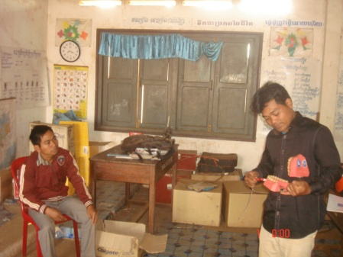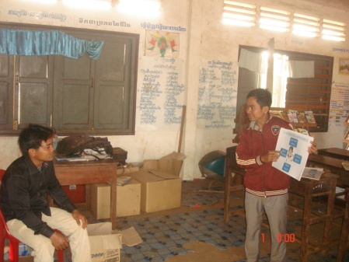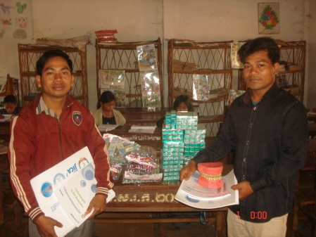
Fig.1 (Oral Health Education By Teachers at Ou Te Thmey PS )
Fig.2 (Oral Health Education By Teachers at Lao Romeat PS )
Fig.3 (Received TB, TP, Flipchart & DentalModel By Teachers at Lao Romeat & Ou Te Thmey PS )

- School Monitoring
No | School Name | Date | Number of students Participated | Number of Oral Health Chapter Provided | Grade | Brushing Day | Oral Health Education Day
1 | Pou Rolar PS | 14th- Mar | 17 | 5&6 | 4,5&6 | Mon & Fri | Thu/2nd Week
2 | Leng Choung PS | 15th- Mar | 38 | 9&11 | 3&4 | Mon & Fri | Thu/2nd Week
3 | Poutrou Leu PS | 17th- Mar | 9 | 5 | 2 | Mon & Fri | Thu/3rd Week
4 | Poutrou Krom PS | 17th- Mar | 11 | 1&2 | 4 | Mon & Fri | Thu/3rd Week
5 | Pou Zam PS | 18th- Mar | 26 | 10 | 5 | Everyday | Thu/3rd Week
 | Dak Dam | 19th- Mar | No Class |  |  | Mon & Fri | Thu/3rd Week

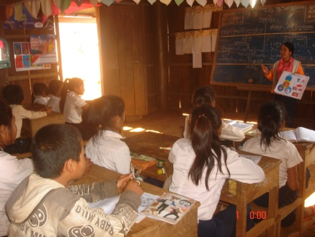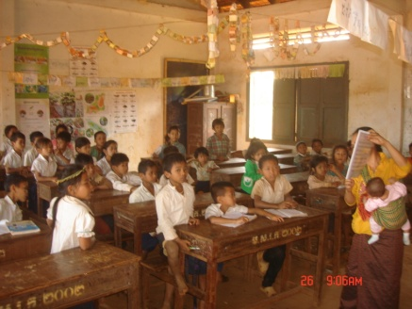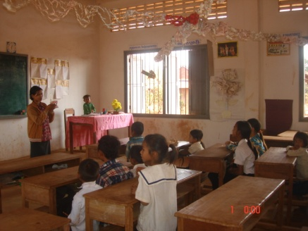
Fig.6 (Oral Health Education by Teacheer at Poutrou Leu PS)
Fig.5 (Oral Health Education by Teacheer at Leng Choung PS )
Fig.4 (Oral Health Education by Teacheer at Pou Rolar PS )

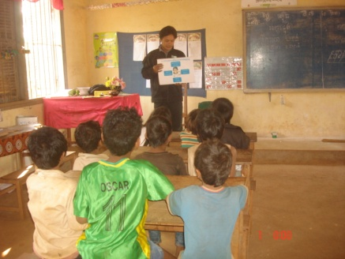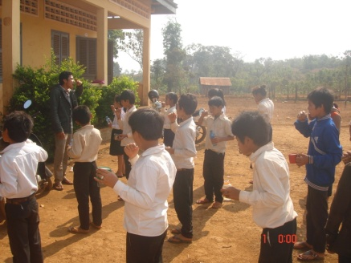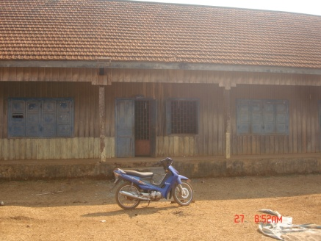
Fig.9 (Dak Dam PS Students Start Short-Term Vocation Early)
Fig.8 (Oral Health Education by Teacheer at Pou Zam PS)

Fig.7 (Oral Health Education by Teacheer at Poutrou Krom PS)

- Community Project
- Health Center Follow-Up
No | Health Center Name | Date | Number of Villagers Participated | Number of Chapter Provided
1 | Pichreada | 15th- Mar | 1 | 1-11
2 | Ou Reang HC | 19th- Mar | 5 | 1-11

After OISDEC staff provided Oral Health Education by flipchart to HC staff, we have flexible schedule to follow-up their oral health education at each health center!
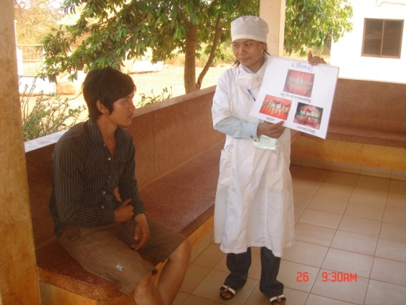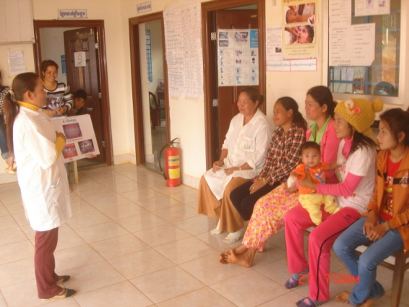
Fig.11 (Oral Health Education to Villager by Ou Reang HC Officer)

Fig.10 (Oral Health Education to Villager by Koh Nhek HC Officer)

- Other Activities

- Participated in SETRA Project
SETRA to Battambang province is really welcomed by PHD the fact that they have prepared appropriate place with some material and electricity socket to make it easy for SETRA team to provide dental care education as well as dental treatment to villagers and students at school close to the HC.
Furthermore, HC director & staffs have show their gratitude and provide very sweet coconut juice to SETRA team because it is a bit late for their lunch time!

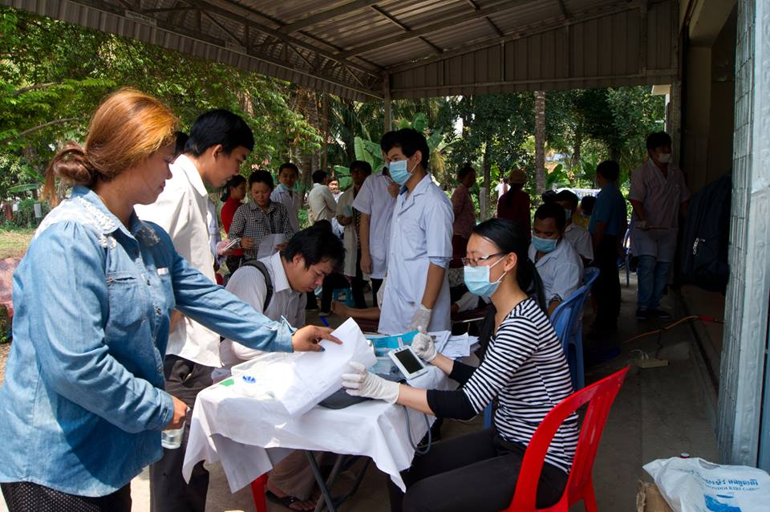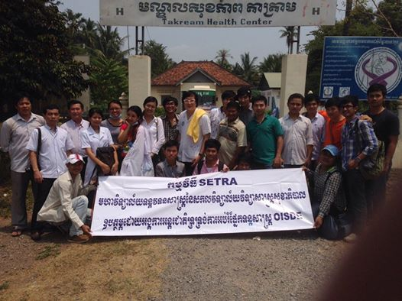
Fig.13 (Take Picture after Finish Oral Education & Treatment at Ta Kream Health Center
Fig.12 (Help Students to Record Oral Health Status of Villagers)

- Participate in Mondulkiri NGOs Network Meeting
There are 14 Health NGOs joined the MNN meeting in order to emphasize the role of Sub-Health Committee and its directors, vice-director as well as secretary. As result, the NGOs Network meeting will be holding one week before the monthly Pro-TW Meeting hosted by PHD. Director of Sub-Health Committee will inform to all member about the date of meeting and all of health NGOs will discuss and finalize the potential issue in the meeting to be raised up in the Pro-TW Meeting. In addition, we could also share the information as well as the challenge problem to the committee in case we need some help, advice, recommendation or solution from member of Health Committee.
As final result, IPHIA Organization has been elected as Director, Caritas as Vice-director and AFH as Secretary of Sub-Health Committee.

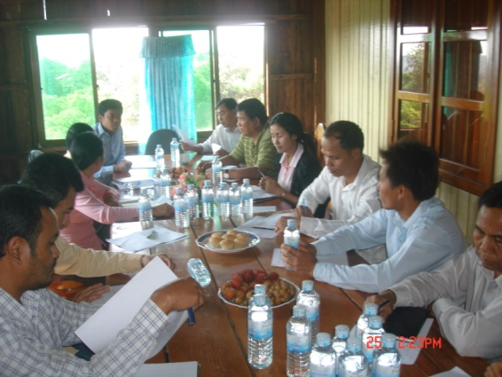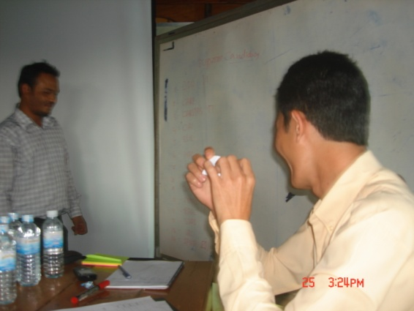
Fig.15 (Vote for Position of Director of Sub-Health Committee)

Fig.14 (Detail Reading about the Role of Sub-Health Committee)

Made By: Mr. Meng Sokhalay
Project Coordinator
Date: 31th March 2014

